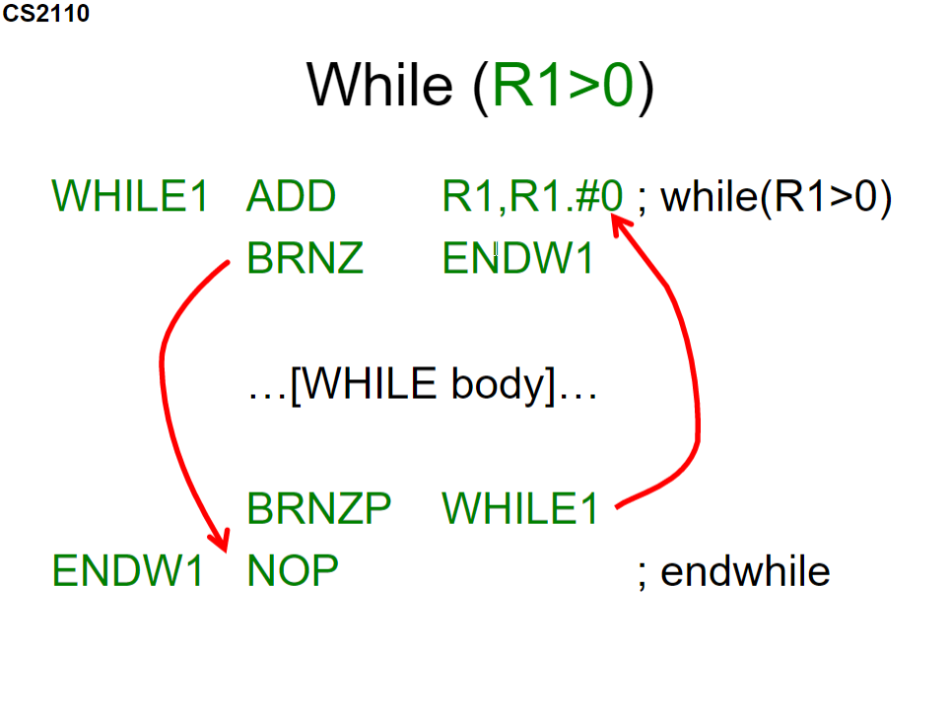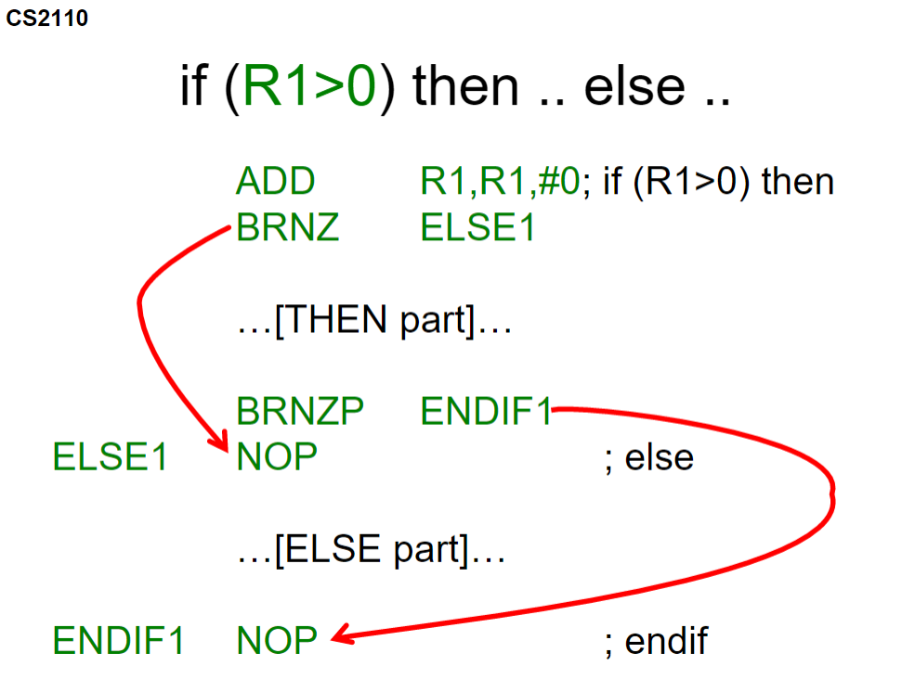**Assembly Code Templates**

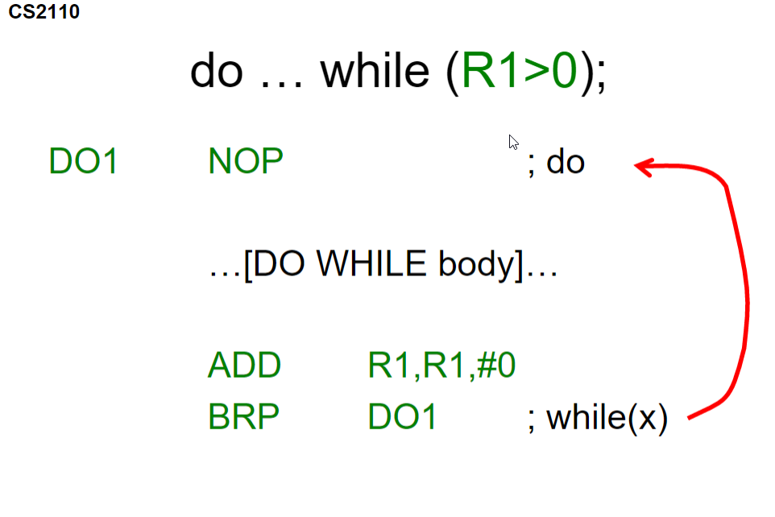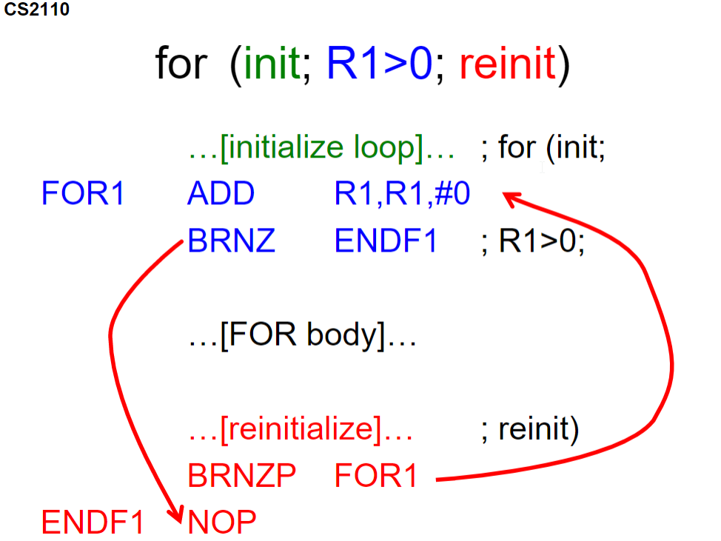

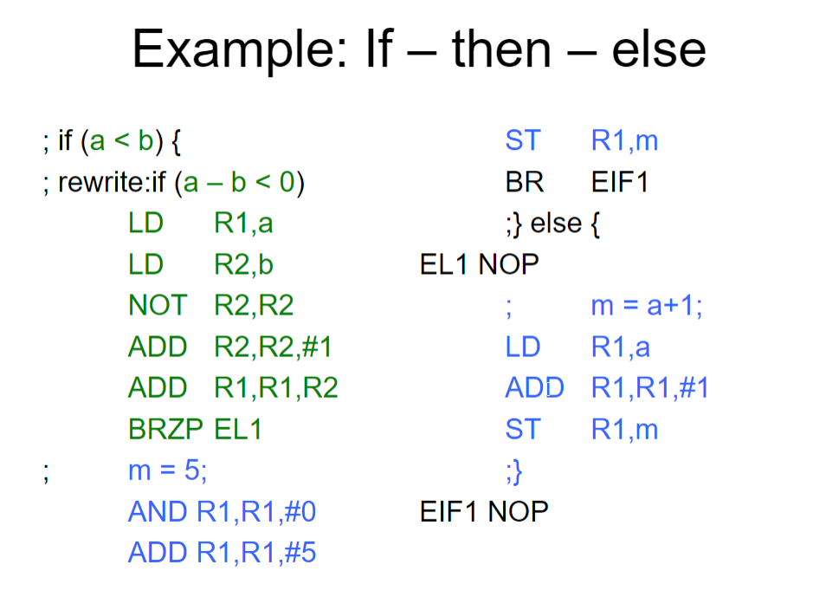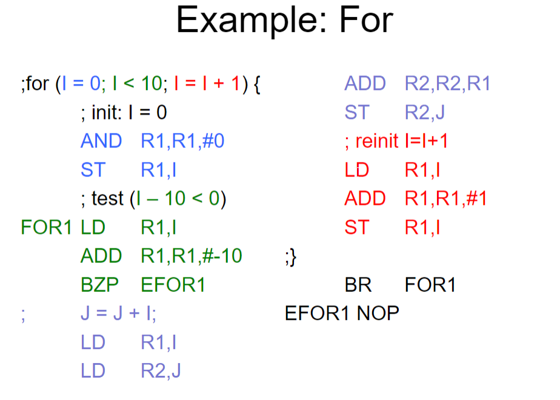

Interrupt – Driven vs Polling

* Interrupt is essentially a wire that lets the CPU know that a character has been input
* Polling checks over and over whether a character has been typed or not

Keyboard has a status register that is memory mapped to xFE00, and a keyboard data register mapped to xFE02

KBSR uses only 1 bit. Uses bit 15 instead of bit 0 as it is a signed bit and sets the end condition code to negative if the status register is 1